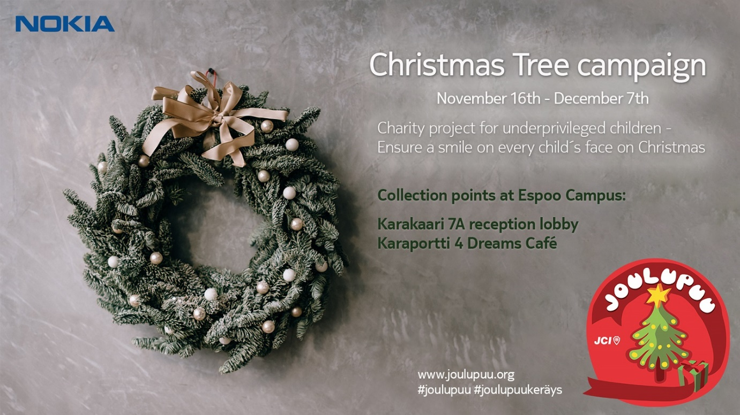

# Joulupuu - Christmas Tree Campaign 2020 at Espoo Campus until Dec 7

On Christmas Eve, every child hopes to find a present under the Christmas tree. Joulupuu (Christmas Tree) campaign has started again and this year it’s needed maybe more than ever before because of the increased need for help due to COVID-19. Unfortunately quite a few will be disappointed. In Finland, there are thousands of underprivileged children, who will not be able to celebrate Christmas with their families. There are over 10 000 children under child welfare care in capital area alone, and the number is increasing. The aim of the Joulupuu campaign is to collect presents for those children who might not get one from anyone else.

Join our effort in bringing Christmas spirit and joy to these children. We aim to collect presents for all ages (between 0-17 years) who are within child welfare care in Finland. Last year, the campaign generated over 88 000 presents in Finland out of which Nokia’s contribution was almost 700 presents. This year, we want to challenge each and every one to contribute. All of the Nokia offices in Finland participate in the campaign also this year.

## **Collection points at Espoo Campus on Nov 16 – Dec 7**

Bring a new or a self-made present ready-wrapped to Nokia’s Joulupuu collection point:

* **Karakaari 7A reception lobby**
* **Karaportti 4 Dreams Café**
* Please attach a label card (available at the collection point) with ready marked gender and age (e.g."Boy 15 years" or "Girl 6 years") to your present. Then just add a short description of the content to the card.
* **Note. Please don’t wrap any used time-worn/broken items as your gift may be the only Christmas present the child gets.**
* Contact persons for the campaign: Pirjo Nurminen (Karakaari 7A); Laura Kemppilä (Karaportti 4, Dreams Café)

## **Other ways to participate in the Christmas Tree campaign:**

* You can participate also at any of the other official Joulupuu collection points. You can find the list of the collections points [here](https://joulupuu.org/muu-suomi/), the list will be updated during November.
* You can also participate by purchasing a gift via the [Minunlahjani.fi](https://minunlahjani.fi/joulupuu/)website, in which case the gift will be delivered to the recipient ready-wrapped. The wrapping cost is 2.50€ and is automatically added to the shopping cart per product. The Minunlahjani.fi online store will deliver the collected Christmas gifts in 2020 to children in Turku, Tampere, Jyväskylä and the Helsinki metropolitan area.
* You can also participate by making a monetary donation. Detailed information about how to make a monetary donation will be updated to [joulupuu.org/](https://joulupuu.org/)website during November.

The campaign is organized together with the Junior Chambers who are co-ordinating the project. All presents will be delivered to the local social welfare authority who will take care of distributing the presents to the right addresses well before Christmas.

Thank you in advance and enjoy the holiday spirit!

*Nokia Finland Volunteering team*